Application & Ide configuration

1. Open github <https://github.com/ZeroToHero-2015/JavaDocs> repository and fork-it to your user



1. Navigate to the forked version and clone it to your local projects workspace.
2. Open the cloned project into IntelliJ IDEA
3. Run maven clean install
4. Run maven tomcat:deploy-only under the tomcat plugin
5. Open browser and insert <http://localhost:8082/web-container/> url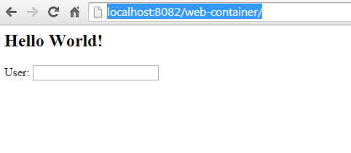
6. Insert some text into “User” input press enter and wait for server response

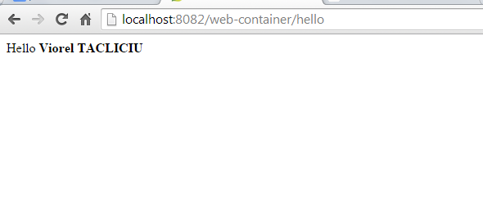

1. If you reach this step please stop for a while
2. Open IntelliJ IDEA Settings  or File->Settings menu, navigate to Plugins(place plugins in the search field) , click Browse repositories… button and search for RemoteSynchronizer plugin. Click Install plugin button , Ok and Restart button if appears. If it not appears then you must restart IntelliJ IDEA manually.

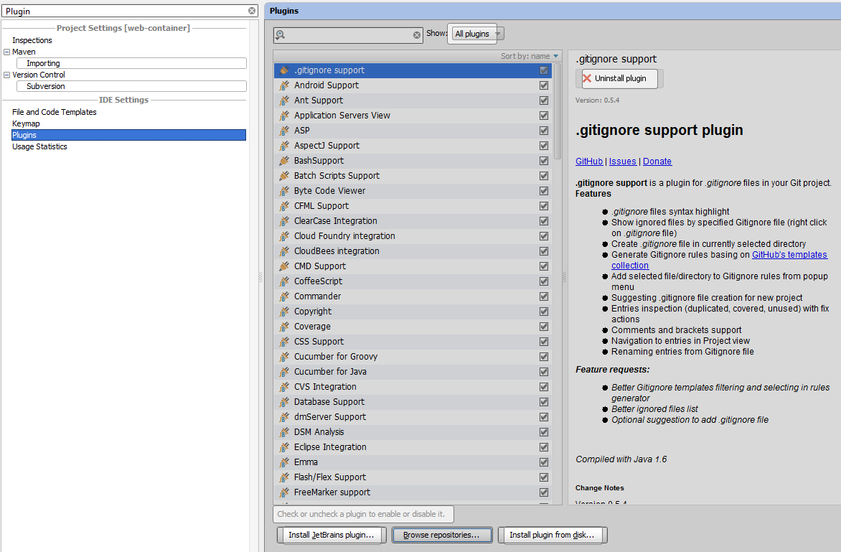

1. Open IntelliJ IDEA Settings  or File->Settings menu, navigate to Remote Synchronizer plugin

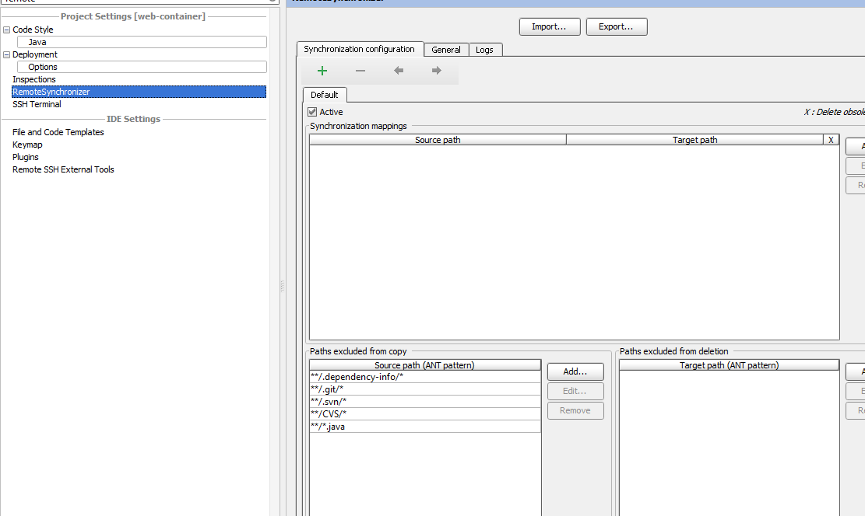

Click Add button and in the Source path you must select the path to your webapp folder from the current project; in the Target path you must select %CATALINA_HOME%\webapps\web-container and press Ok.

1. Look for index.jsp file under your project. Replace text **<h2>Hello World!</h2>** with text **<h2>Enjoy Zero To Hero</h2>**
2. Press CTRL+ NumPad* or Right click on inde.jsp -> Remote synchronize -> Synchronize this
3. Open the RemoteSynchronizer window (placed in the bottom window) and ckeck if there is a message

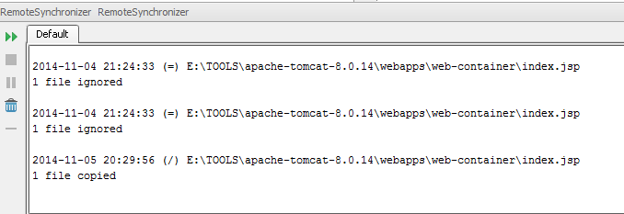

1. In the browser navigate to <http://localhost:8082/web-container> and check for the modification